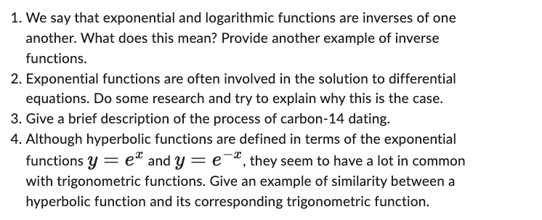

- To solve for an exponential you need to using logarithmic rules to solve for a log you need to apply exponential. A way we can think about this is looking at the power rule. 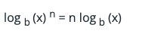
In the power rule we use knowledge about the relationship of exponentials and logarithmic by moving variable or full constants to make solving our problem easier to solve.

- Exponential functions are modeled using differential equations to make it easier to understand. This is mostly used because this a natural process which exist in nature such as, half-life of radioactive material, modeling the growth of a population, or bacteria growth.
- Carbon-14 Dating is method used to date organic material. To sum up the process, it involving calculating cosmic radiation, carbon-14, which has a half-life of 5,700 years, in a material. The following is the differential equation for carbon dating.
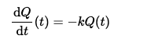
The differential equation models how to find the age of an organic material. The formula breaks down to (k) is a constant which is proportionality to the half-life. (t) is the time.

4 Hyperbolic functions are not oscillatory, they are just linear while Trigonometric functions are oscillatory such as sine or cosine. This being said I think of a hyperbolic like a 1 way Trigonometric function.

